Software Requirements Specification

for

Notable

**Version 1.4 approved**

**Prepared by Dallas Rihm, Alex Van Ess, Riki Schulz**

**Team1**

**12/12/2017**

**Table of Contents**

**Table of Contents** **ii**

**Revision History** **ii**

**1.** **Introduction 3**

1.1 Purpose 3

1.2 References 3

**2.** **Overall Description 3**

2.1 User Classes and Characteristics 3

2.2 Operating Environment 4

2.3 Design and Implementation Constraints 4

2.4 Assumptions and Dependencies 4

**3.** **External Interface Requirements 4**

3.1 User Interfaces 4

3.2 Hardware Interfaces 6

3.3 Software Interfaces 6

3.4 Communications Interfaces 6

**4.** **System Use Cases 7**

4.1 The user signs up on website and creates an account (U1) 7

4.2 The user logs into the website (U2) 8

4.3 The user logs out of the website (U3) 8

4.4 The user creates note (U4) 9

4.5 A note autosaves (U5) 9

4.6 The user opens a note (U6) 10

4.7 The user deletes note (U7) 10

4.8 The user changes color of note (U8) 11

4.9 The user wants a birdseye/larger view of all their notes (U9) 11

4.10 The user wants to print a copy of all of their notes (U10) 12

4.11 The user edits a note (U11) 12

**5.** **Other Nonfunctional Requirements 13**

5.1 Performance Requirements 13

5.2 Safety Requirements 13

5.3 Security Requirements 13

5.4 Software Quality Attributes 13

**6.** **Other Requirements 13**

**7.** **System Requirements Chart 13**

**Appendix A: Analysis Models 14**

**Appendix B: To Be Determined List 14**

**Revision History**

|  |  |  |  |
| --- | --- | --- | --- |
| **Name** | **Date** | **Reason For Changes** | **Version** |
| Alex Van Ess | 10-15-2017 | Completed Sections 1 and 2 | 1.0 |
| Alex Van Ess | 11-1-2017 | Added use case diagram to Section 4 | 1.1 |
| Dallas Rihm | 11-24-2017 | Completed initial use cases (Section 4) | 1.2 |
| Alex Van Ess | 12-05-2017 | Completed Section 3 (External Interfaces) | 1.3 |
| Alex Van Ess | 12-11-2017 | Modified use cases to reflect final product.  Added ERD diagram to Appendix A.  Added TBD items to Appendix B.  Final edit of document. | 1.4 |

# Introduction

## Purpose

The software requirements detailed in this document apply to the Notable application version 1.4. The purpose of Notable is to provide users with an interactive web application to manage their information in the form of notes. The scope of the project is to build an entire web application from scratch that allows users to create and log into an account where they can add, modify, view, delete, and save notes to their account.

## References

*None*

# Overall Description

## User Classes and Characteristics

**Administrator** – Administrator user classification will be given to all members of the software development team who both own and develop the application. The administrator role will have access to all features available in the application so that each can be tested as part of development. This includes features not available to customers such as security permissions to access to the database where user and note information is stored.   
  
**Regular** – Regular users are the most important user class to satisfy since they will be the everyday consumers of the product. Since our application will be used primarily by regular users it is important that all functionality tied to this user class is working properly. Regular users will have access to all customer facing features of the application such as account creation, log in, creating a note, editing a note, deleting a note, changing the color of a note, viewing their entire note board, printing a copy of their notes, and signing out. The only feature restricted to regular users is access to the database or other user accounts.

## Operating Environment

This web application will operate in firefox version 56.0 and up as well as chrome version 61.0 and up. Hardware required to support the application is any pc capable of installing and running the above web browsers.

## Design and Implementation Constraints

The implementation of features of this product will be constrained by developer’s time resources and experience. With a team of three developers who also have jobs and other commitments, time will be a limiting factor on the completion and amount of features in this project. The team members also have varying levels of knowledge of different programming languages. The lack of knowledge of web based technologies such as ASP.net will limit how we are able to implement our login and database functionality. A new language (PHP) will need to be learned and will affect our ability to connect to a database to store user information.

## Assumptions and Dependencies

This project assumes that the user does not have any extensions applied to their web browser. Extensions are not accounted for and may affect the display or functionality of the web application.

This project also assumes that all javascript, html, and php technology used will continue to be compatible with future versions of both firefox and chrome web browsers. Another assumption made is that the site will experience relatively low concurrent user traffic and does not account for high volume traffic and its effect on performance. Finally, our project depends on the nwtc bitweb hosting service in order to be posted and viewed on the Internet.

# External Interface Requirements

## User Interface

* Login and Logout button standards: Located at bottom of title section, blue, consistent size
* All application pages will follow the format: Title section at top of page, navigation on left side of page (except sign up page), and content section on the right hand side of page
* All pages follow the color scheme: Gray background, blue title section, white background for content and navigation sections
* All feature controls have user familiar icons:
  + To delete a note: Trash can icon
  + To add a note: Page with a plus icon
  + To display a note board view: Noteboard icon
  + To view a print version: Printer icon
* Error messages will display when form validation errors occur
* All application controls will highlight on hover
* New note title and text appears in gray font until edited
* Edited note text appears as black
* All newly added notes are given default title “New Note” in navigation bar
* All newly added notes are given default yellow color
* All application pages are reachable in 3 or less clicks

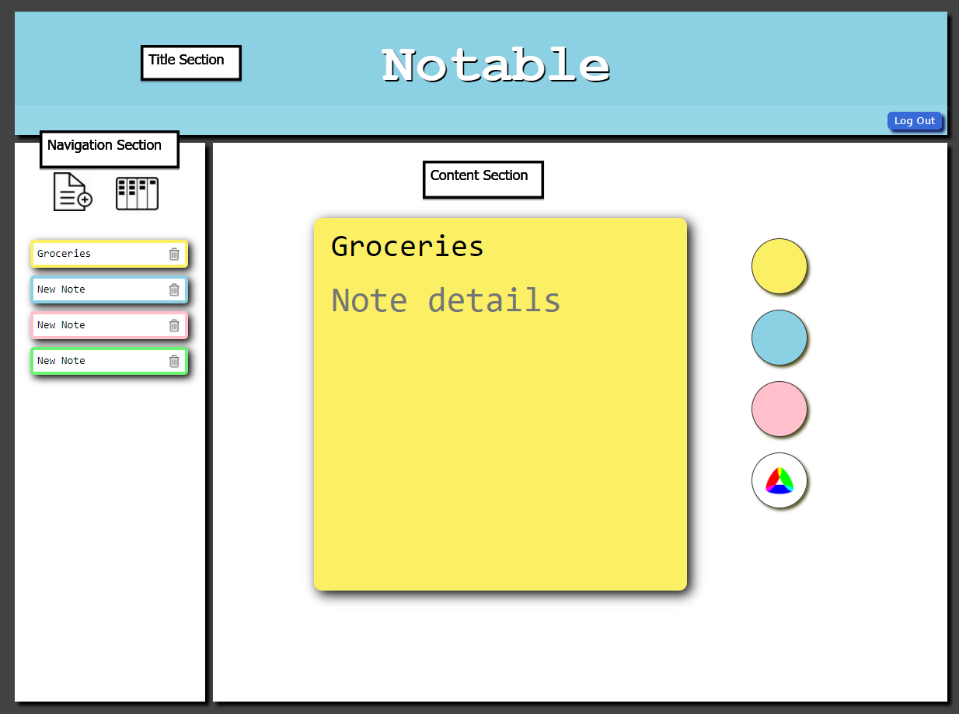

## Hardware Interfaces

The application will require users to use a mouse, keyboard, and monitor to interact with the application. The application will display on the monitor, allowing the user to navigate the product using the mouse and enter information using the keyboard.

## Software Interfaces

In order for us to store and retrieve user note information our web application interfaces with a MySQL database (notableteamdev) by using phpMyAdmin version 4.7.4. We use our database to store user account information such as first name, last name, username, email, and password so that users can login. We also store the title, content, and color of each note to an account so that each time a user logs in all of their information is retrievable and displays exactly as it was the last time they logged in. Each user is given a unique user ID in the database which is used when retrieving the appropriate notes tied to that account. The application is hosted by nwtc bitweb which allows the web app to be posted and viewed on the internet.

## Communications Interfaces

Notable does not connect to any external applications or services to gather data. The only communication interface that Notable uses is a form (account creation form) that is sent via the web browser to the server. The data is given freely by the user and stored in a private database on the server that no one outside of the development team will have access to. All browser-server communication is done using HTTP. FTP is the protocol used to get our files to the server, however the user does not see this information.

# System Use Cases

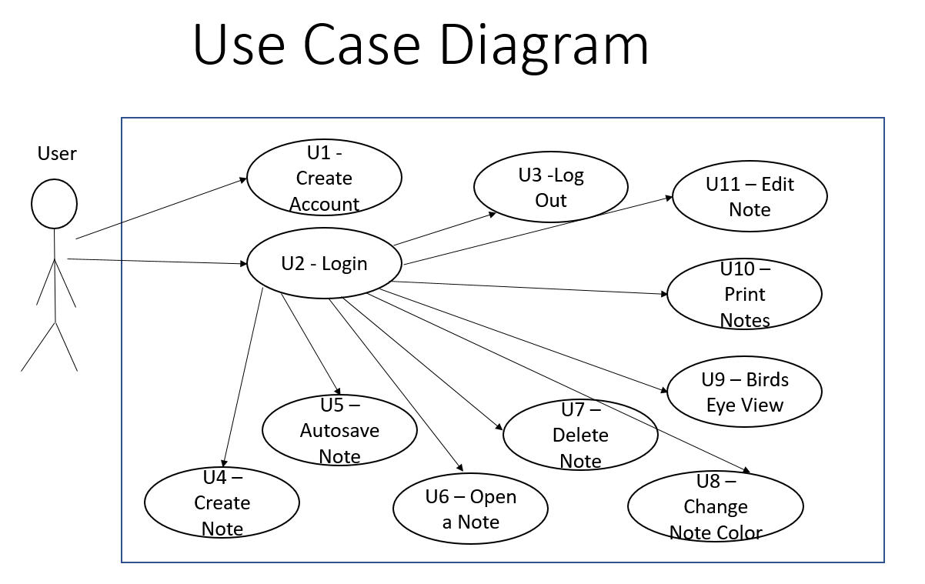

## The user signs up on website and creates an account

1. **U1**

2. **Objective** - The user is able to sign up and create an account.

3. **Priority** - High

4. **Source** - Tommy Test (End-user)

5. **Actors** - RIU (Random Internet User)

6. **Flow of Events**

6.1. **Basic Flow**

6.1.1. The user enters their new account details (First Name, Last Name, Email, Username, Password).

6.1.2. The user clicks the “Sign Up” button.

6.2. **Exception Flow 1**

6.2.1. Username is already taken. Error message displays “Username already chosen. Please try again.”

6.2.2 User must click back button to go back to sign in page and enter new information into form.

6.3. **Exception Flow 2**

6.3.1. The username or password is not entered or is not 8 characters in length. Error message displays “Username and password must be at least 8 characters in length. Please try again.”.

6.3.2 User must click back button to go back to sign in page and enter new information into form.

7. **Includes** - None

8. **Preconditions** – User is on the Noteable sign up page.

9. **Postconditions** – Account is created in database and user is logged in. User lands on their homepage.

10. **Notes/Issues** - None

## The user logs into the website

1. **U2**

2. **Objective** - The user is able to successfully log into the website.

3. **Priority** - High

4. **Source** - Tommy Test (End-user)

5. **Actors** - RIU (Random Internet User)

6. **Flow of Events**

6.1. **Basic Flow**

6.1.1. The user enters their username and password into the login section of the homepage after creating an account.

6.1.2. The user clicks “Login” button.

6.1.3. The user is brought to their home page containing any existing notes that they have created.

6.2. **Exception Flow 1**

6.2.1. The username and password entered do not match a user account in the database.

6.2.2 Error message displays “Username and password are not a match. Try again.”.

6.2.3 User must click back button to go back to sign in page and enter new information into form.

7. **Includes** - U1 as a precondition.

8. **Preconditions** – User is on the Noteable sign up page and has already created an account.

9. **Postconditions** – The user is logged in and taken to their notable home page containing all of their saved notes.

10. **Notes/Issues** - None

## The user logs out of the website

1. **U3**

2. **Objective** - The user is able to successfully logout of their account.

3. **Priority** - High

4. **Source** - Tommy Test (End-user)

5. **Actors** - RIU (Random Internet User)

6. **Flow of Events**

6.1. **Basic Flow**

6.1.1. The user clicks the “logout” button.

6.1.2. The user is brought to the Notable sign up page.

7. **Includes** - U2 as a precondition

8. **Preconditions** – The user has an account made and is logged into their account.

9. **Postconditions** – The user is brought back to the Notable sign up page.

10. **Notes/Issues** - None

## The user creates note

1. **U4**

2. **Objective** - A user is able to successfully create a note.

3. **Priority** - High

4. **Source** - Tommy Test (End-user)

5. **Actors** - RIU (Random Internet User)

6. **Flow of Events**

6.1. **Basic Flow**

6.1.1. The user clicks the  button on the navigation bar.

6.1.2. A new note displays in the content section of the page and the title and content fields are editable.

6.1.3 A new note tab is added to the navigation section.

6.2. **Exception Flow 1**

6.2.1. The user already has the maximum of 12 notes created. System displays an alert telling the user “Note maximum reached.”

6.2.2 The new note is not created.

7. **Includes** - U2 is a precondition

8. **Preconditions** – User has created an account and is logged in. The user is on their homepage.

9. **Postconditions** – A new note is added to their account and is stored in the database. A new note tab displays at the bottom of the navigation section.

10. **Notes/Issues** - New notes are given a default color of yellow. New notes are given the title “New Note”.

## A note autosaves

1. **U5**

2. **Objective** - The users notes and their contents are saved to the database.

3. **Priority** - High

4. **Source** - Tommy Test (End-user)

5. **Actors** - RIU (Random Internet User)

6. **Flow of Events**

6.1. **Basic Flow**

6.1.1. The user completes any action on the page (add note, view note, type, choose a color, clicks birds eye view, logs out, etc.).

6.1.2. All notes and their contents are automatically saved to the database.

7. **Includes** - U2 as a precondition

8. **Preconditions** – A user has an account and is logged into their account.

9. **Postconditions** – All user notes are saved to the database.

10. **Notes/Issues** - None

## The user opens a note

1. **U6**

2. **Objective** - A user is able to view a different note than the note currently being displayed in the content section.

3. **Priority** - High

4. **Source** - Tommy Test (End-user)

5. **Actors** - RIU (Random Internet User)

6. **Flow of Events**

6.1. **Basic Flow**

6.1.1. The user clicks a note in the navigation section that is different than the note currently on display.

6.1.2. The note information is retrieved from the database.

6.1.3. The selected note displays in the content section of the page. The note content and color match the stored values in the database.

7. **Includes** - U2 and U4 as preconditions

8. **Preconditions** – A user is logged in and has multiple notes created

9. **Postconditions** – The note that was clicked displays in the content section. The note content and color match what is stored in the database.

10. **Notes/Issues** - None

## The user deletes note

1. **U7**

2. **Objective** - The user is able to delete a note.

3. **Priority** - High

4. **Source** - Tommy Test (End-user)

5. **Actors** - RIU (Random Internet User)

6. **Flow of Events**

6.1. **Basic Flow**

6.1.1. The user clicks the symbol next to the note they want to delete.

6.1.2. The chosen note is removed from the account and the navigation section.

6.1.3. The first note in the navigation section is put on display in the content section.

7. **Includes** - U2 as a precondition

8. **Preconditions** – The user is logged in and has at least one note on their account.

9. **Postconditions** – The chosen note is removed from the database and the account.

10. **Notes/Issues** - None

## The user changes color of note

1. **U8**

2. **Objective** - The user is able to change the color of a note.

3. **Priority** - Low

4. **Source** - Tommy Test (End-user)

5. **Actors** - RIU (Random Internet User)

6. **Flow of Events**

6.1. **Basic Flow 1**

6.1.1. The user opens a note or has an existing note on display.

6.1.2. The user clicks one of the predetermined color bubbles (yellow, blue, or pink).

6.1.3. The background color of the currently displayed note changes to the color selected.

6.1.4 The border color of the note tab in the navigation section changes to the selected color.

6.2. **Alternate Flow**

6.2.1. The user opens a note or has an existing note on display.

6.2.2. The user clicks the custom color bubble.

6.2.3. The user uses the color picker popup to select a custom color.

6.2.4. The user clicks “OK” on the color picker popup.

6.2.5. The background color of the note is changed.

6.2.6 The border color of the note tab in the navigation section changes to the selected color.

7. **Includes** - U2 as a precondition

8. **Preconditions** – The user is logged into their account and has at least one note.

9. **Postconditions** – The color of the displayed note changes to the selected color. The border color of the corresponding note tab in the navigation section changes to the selected color.

10. **Notes/Issues** - None

## The user wants a birdseye/larger view of all their notes

1. **U9**

2. **Objective** - The user is able to view all of their notes on one screen.

3. **Priority** - Low

4. **Source** - Tommy Test (End-user)

5. **Actors** - RIU (Random Internet User)

6. **Flow of Events**

6.1. **Basic Flow**

6.1.1. The user clicks the  button.

6.1.2. All of the user’s notes and their contents are displayed in a birds eye fashion.

7. **Includes** - U2 as a precondition

8. **Preconditions** – The user is logged in and has at least one note.

9. **Postconditions** – The user is viewing all of their notes on one page.

10. **Notes/Issues** - All notes should display their proper color and content in birds eye view.

## The user wants to print a copy of all of their notes

1. **U10**

2. **Objective** - The user is able to print a black and white copy of the contents of their notes.

3. **Priority** - Low

4. **Source** - Tommy Test (End-user)

5. **Actors** - RIU (Random Internet User)

6. **Flow of Events**

6.1. **Basic Flow**

6.1.1. The user clicks the  button.

6.1.2. From the birds eye view the user clicks the button.

6.1.3 The print view screen displays a black and white printable copy of the user’s notes.

6.1.4 The user clicks print to print a copy of the notes.

7. **Includes** - U2 as a precondition

8. **Preconditions** – The user is logged in and has at least one note.

9. **Postconditions** – The user has a printed black and white copy of their notes.

10. **Notes/Issues** - None.

## The user edits a note

1. **U11**

2. **Objective** - A user is able to successfully edit a note.

3. **Priority** - High

4. **Source** - Tommy Test (End-user)

5. **Actors** - RIU (Random Internet User)

6. **Flow of Events**

6.1. **Basic Flow**

6.1.1. The user clicks the note that they wish to edit from the navigation section.

6.1.2. The note displays in the content section of the page.

6.1.3. The user clicks the note title text area and makes changes.

6.1.4 The title on the corresponding note tab in the navigation section updates as the user types.

6.1.5 The user clicks the note details text area and adds/ modifies the content of the note.

7. **Includes** - U2 is a precondition

8. **Preconditions** – User has created an account and is logged in. The user has at least one note.

9. **Postconditions** – The note content is modified and saved to the database.

10. **Notes/Issues** - None.

# Other Nonfunctional Requirements

## Performance Requirements

*See section 7 requirements 23-27*

*Per Instructor Scott Peterson this section is not required for this course.*

## Safety Requirements

*See section 7 requirements 25-32*

*Per Instructor Scott Peterson this section is not required for this course.*

## Security Requirements

*See section 7 requirements 35-42*

*Per Instructor Scott Peterson this section is not required for this course.*

## Software Quality Attributes

*See section 7 requirements 55-62*

*Per Instructor Scott Peterson this section is not required for this course.*

# Other Requirements

None

# System Requirements Chart

*Per Instructor Scott Peterson this section is not required for this course.*

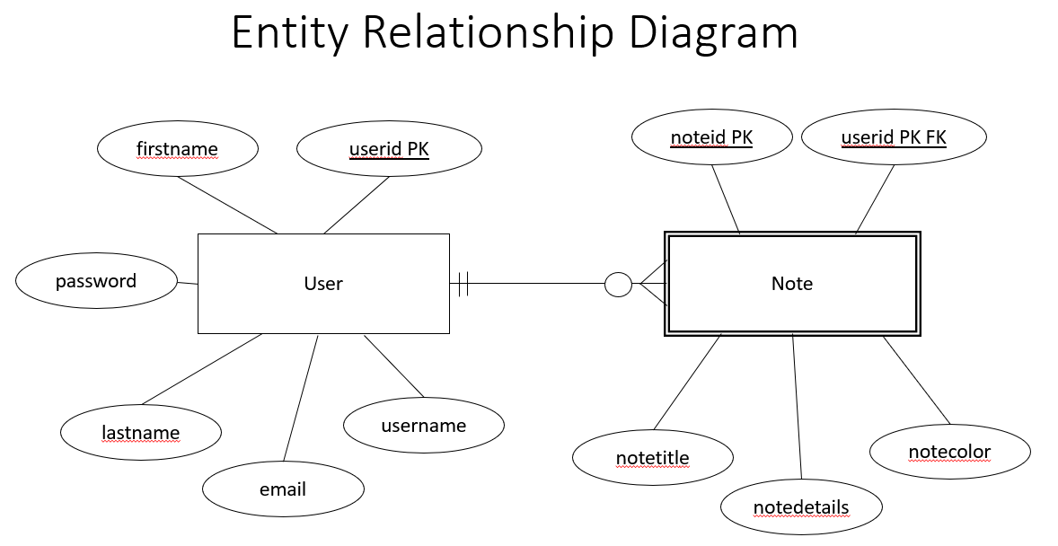**Appendix A: Analysis Models**

**Appendix B: To Be Determined List**

Items left to be finished:

1. Sign up validation errors displaying on actual sign up page instead of directing to new page.
2. Add ability to email the contents of a note.
3. Password encryption in database.
4. Ability for users to deactivate their account.
5. Add validation to check for valid email address.